
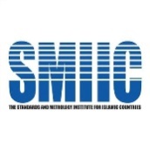

WHS 2026
Abstract Template

Title: Template for Abstract Submission – WHS 2026
Authora,, Co-Authorb,
a Institution Name, Department, City, Position, Country. E-mail, Phone Number,
b Institution Name, Department, City, Position, Country. E-mail, Phone Number

A R T I C L E I N F O |  | A B S T R A C T (min. 300 words)
Keywords (5 words): |  | This template is for preparing an abstract or manuscript related to your speech or presentation for the World Halal Summit 2026 on Halal studies.  The objectives and results of the research must be included and clearly stated. The abstract should be a minimum of 300 words. If you have the full content of your speech, you may also submit it in addition to the abstract.

